Professional Development Workshop # 12: Engineering Education & Research vs Engineering Design

Speaker: Mr. Eugene Rutz, MS, PE
Date: Tuesday, July 9, 2019
Time: 11:00 AM – 12:00 Noon
Venue: University of Cincinnati, Baldwin, Room 741

Prepared by:
Lynn Brant, Kings High School, Kings Mills, Ohio
RET Participant for Project #4: “Signalized Intersection Design”

This session was given by Mr. Eugene Rutz, MS, PE, on Tuesday, July 9, 2019 from 11:00 AM – 12:00 noon at the University of Cincinnati in Baldwin, room 741. Mr. Rutz is the Academic Director in the College of Engineering & Applied Science at the University of Cincinnati. Eugene has oversight of the combined Bachelor’s and Master’s programs, the Master of Engineering programs and the collaborative program with regional high schools.

Mr. Eugene Rutz opened the RET session by giving a brief introduction to his diverse career. He began his career as a nuclear engineer with the Zimmer Power plant. When it closed, he worked for General Electric on a project related to subatomic particles. All of his experiences led to his current role as an academic advisor for the University of Cincinnati’s College of Engineering and Applied Science (CEAS). His introduction was followed by RET participants introducing themselves to him.

Mr. Rutz’ objectives for his presentation were to discuss the relationship between science and engineering. Participants were asked to keep the environment of the session conversational rather than a formal lecture. The first topic of discussion was Science, Technology, Engineering and Math (STEM) education. As shown in figure 1, Mr. Rutz provided his views of STEM education. He explained that the largest misconception was the component of technology. Many people define technology as the software and information technology. He was impressed by an RET participant’s definition of “any human made tool that helps one complete a task.” He concluded the discussion by defining STEM as an “integration of all of these ideas to solve real-world problems to make our lives better.”

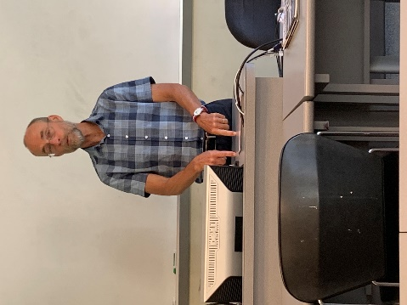

Figure 1: Mr. Rutz providing his views of STEM education

During the next topic of discussion, Mr. Rutz provided the reasons that high school students give for not choosing engineering as a career choice. He countered those reasons with the following three examples of why students elect to major in engineering:
- I want to change the world.
- My robotics coach thought I could be an engineer.
- I want to help people.

Mr. Rutz offered that the most important reason for selecting engineering as a career needed to be that the student wanted to help people and not necessarily because he or she liked mathematics and science.

Mr. Rutz provided current data about the demographics of students entering the engineering field and the job market. He provided the statistic that 20% of the University of Cincinnati’s incoming engineering class in the fall of 2019 are females, up by nearly 7%. In addition, the STEM field has 1 qualified individual per 1.9 job listings with projected growth of about 65,000 new jobs for the field of engineering from 2014-2024. Figure 2 compares the rate of growth of first engineering degrees between countries from 1983-2006. This led to a discussion about the STEM labor market and the job shortages and surpluses in the public and private sectors.

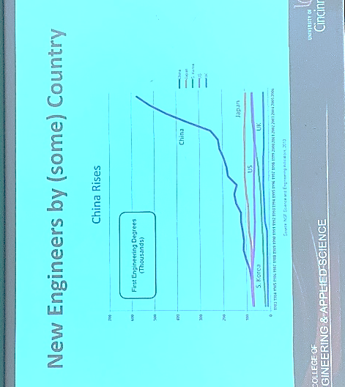

Figure 2: Engineer Training Comparison Chart

Mr. Rutz then discussed the difference between Engineering Technology and Engineering. He provided the necessary high school preparation of students and the average test scores for the ACT/SAT that were accepted into UC’s CEAS for both Engineering and Engineering Technology. Mr. Rutz explained the uniqueness of UC’s co-op requirement and how it is the “ultimate scholarship,” since students essentially earn enough money to pay for college through its design.

The final discussion, as shown in figure 3, was on research vs engineering design. Mr. Rutz stressed that science is research to obtain one solution and engineering has many possible solutions but always has constraints. It’s often feasible in engineering to solve the wrong problem which results in refining the solution. Mr. Rutz ended his presentation by encouraging RET participants to be careful to design engineering experiences and not science experiments for their students.

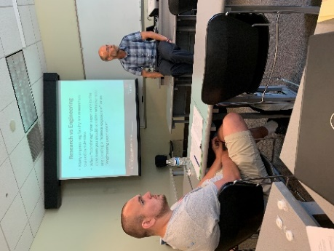

Figure 3: Mr. Rutz guiding dialogue about research vs engineering

